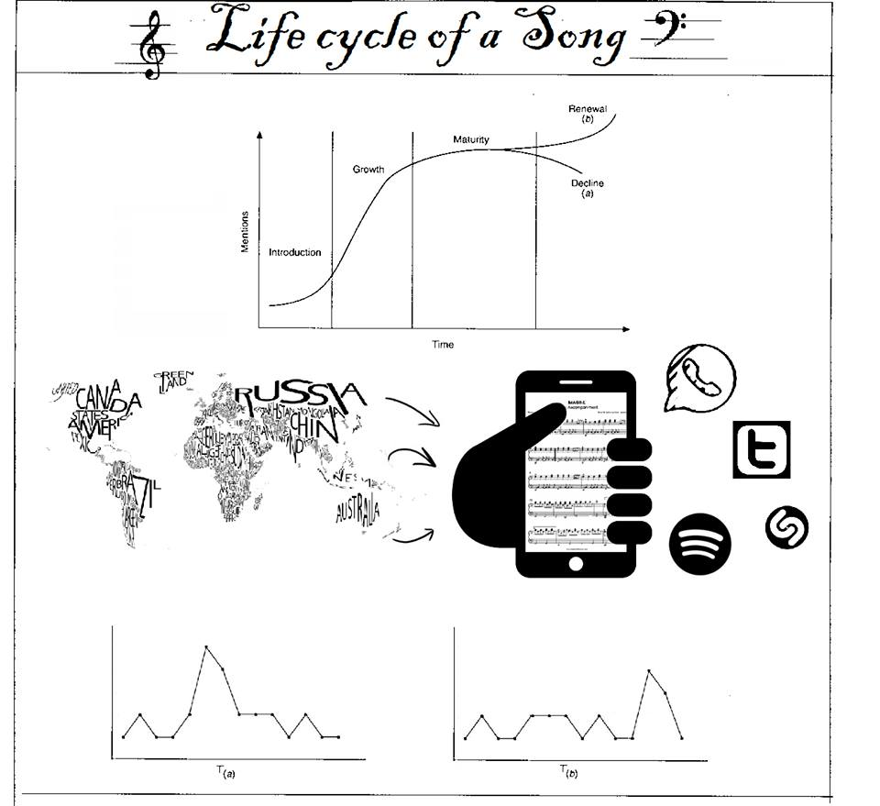

# Social Physics: What makes a song popular?

There is many answers on this question depending on a person view or opinion. It can be because of the quality of the song, who is singing it, his/her age, is it a male or a female… And sometimes people just like it because he or she is famous or a friend does like.

## Key concepts

**Idea flow** is the spreading of ideas, whether by example or story, through a social network—be it a company, a family, or a city.

This flow of ideas is key to the development of traditions, and ultimately of culture. It facilitates the transfer of habits and customs from person to person and from generation to generation.

Idea flow also depends on the mix of social learning and individual learning.

**Social learning**

This theory, made famous by Albert Bandura, states that social behavior (any type of behavior that we display socially) is learned primarily by observing and imitating the actions of others. The social behavior is also influenced, according to this theory, by being rewarded and/or punished for these actions.

**Living laboratories**

In order to try out new ideas in the real world and to see what works and what does not, we need to construct living laboratories – communities willing to try a new way of doing things.

**Reality mining**

Studies of human interactions based on the usage of wireless devices such as mobile phones and GPS systems providing a more accurate picture of what people do, where they go, and with whom they communicate with rather than from more subjective sources such as a person's own account.

**Fast thinking, slow thinking, and free will**

Fast thinking: operates automatically and quickly, with little or no effort and no sense of voluntary control.

Slow thinking: allocates attention to the effortful mental activities that demand it, including complex computations. Often associated with the subjective experience of agency, choice, and concentration.

## Social Physics

**- What are your goals?**

Try to answer: What makes a song popular? based on five characteristics of the listener namely: gender, age, familiarity, mood and self views

**- What do you need (means)?**

Research that relates to music preferences based on gender, age, familiarity, self views and mood.

**- How do you tackle this (method)?**

Appoint the five characteristics separately to each individual in our team.

**- Conditions and exclusions?**

Our research is depending on research conducted earlier in this field and what we can find about it.

A sixth factor is being mentioned on wikipedia namely season of the year, this factor will be excluded

## Implications of your intervention

We asked ourselves what would happen if we would solely create playlists that confirm to the findings of our research.

gender: music is not mutually exclusive to gender

age: will be excluding songs you might have listened to when younger, during your lifetime music preferences change

familiarty: you dont get unfamiliar music.

People cant have the new tatse of songs .they may feel bored and irritated listening to the same type of songs

self views:

doesn't take into account personal preferences

certain features will be in conflict which each other if these are put together

Familiarity plays an important role in the popularity on the songs.

People generally like the music which have familiar pattern rhythm

Which they usually listen or whether the artist is new or popular one.

In one experiment it is clearly shown that the there is more in the familiar liked music then unfamiliar liked

## Music preference factor Gender

Do men listen to different music than women do?

**Idea flow:**

**Social Learning:** Hall (2007) found that if a certain genre of media (e.g., music, art, etc.) is perceived to be disliked by others, reports of individual use of that particular genre were dramatically lower. Conversely, the use of certain genres that are perceived to be well regarded by other individuals were reported more often. The popularity of a certain genre of music is biased by gender. From the results of the study on musicmachinery.com we can see that genres like pop, dance pop and contemporary are prone to attract female listeners and rock, hip hop and house has a stronger male attraction.[2]

**Living Laboratory/Reality Mining:** Loads of data is available to conduct research in this field for living laboratories we could use Spotify playlists, Twitter feeds, YouTube comments and playlists.

Research can be conducted using these playlists and clusters could be found if there are any significant differences in for example genre and artist compared to gender.

**Fast and Slow Thinking:**

The orderly arrangement of low to higher frequencies is mapped onto the brain much like the way low to high notes are mapped on a piano keyboard. However, not much is known about how the pieces are put back together when we recognize melodies, words, or the scolding sound of someone's voice.[5]

Music will demand your attention in good and bad ways. It will influence you in certain ways and technically your brain is listening to it.[6]

## Music preference factor Familiarity

The following things are based on the experiment based on **Music and Emotions in the Brain: Familiarity Matters[4]**

**Idea flow:** The main objective of this experiment is to know how the familiarity is related for the popularity of the songs.

**Social Learning:** The behaviour or action of the people after listing to the sound is to determine whether the sound was familiar or not and respond according to that.

**Living Laboratory:** People were invited to join the experiment to find their respond on different types of music or sound.

**Reality Mining:** The responds of the people who took part in this experiment was recorded in some data software.

**Fast and Slow Thinking:** The reaction of the participants was fast thinking because their responses where based on the instance of the choice whether they like it or not.

Familiarity plays an important role in the popularity on the songs. People generally like the music which have familiar pattern rhythm which they usually listen. In one experiment it is clearly shown that the there is more in the familiar liked music then unfamiliar liked

## Music preference factor Age

**Social learning:** The research made shows that people prefer particular kinds of music based on their particular personality characteristics that the music satisfies. Which mean that people from a different generation can like or dislike a kind of music because it make the person they prefer acting the way he acts (behaviour) which it may conduct to like the song or dislike it.[7]

**Living laboratory:**The research made shows that surprising a 64 years old is more in search of new song or popular music because they are more curious about what is actually happening in the world.[8]

**Reality mining:** A research made on adolescent shows how it was influencing the way their feel about themselves, it demonstrated the low self-esteem, or how they feel rejected, etc.

It shows how they human is interacting according to his/her age.[9]

**Fast, slow thinking and free will:** The research made on the free will shows how if a person is given a choice to choose music, it shows how the graph is increasing depending on how the listener is getting younger.

For the slow and fast thinking, older generations seems to be choosing the songs after a deep thinking than younger people who doesn’t care as soon as the song is popular.[10]

## Music preference factor Self Views

**Idea Flow:** the idea of this experiment is how music preferences can be influenced by the individual wants that are perceived, especially in males. Music preferences could be used to make self-directed identity claims. Individuals might select styles of music that reinforce their self-views. For examples, individuals with a conservative self-view preferred conventional styles of music, while individuals with an athletic self-view preferred vigorous music.

**Social learning:** the research shows us that people with similar self-views and shared personality traits could also be more likely to have same taste of music. Hence people who recognize themselves in others tend to like and copy the music from people that perceive themselves in a similar way.

**Living laboratory:** A research performed by Rentfrow and Gosling (2003), with thesis which stated that people with high self-perceived intelligence tend to listen Intense and Rebellious music. Genres that were included in the research were rock, alternative and heavy metal. A total of 22 men and 48 women participated with the age ranging from 18 to 53.

**Reality Mining:** The correlation between preference for intense rebellious music and self-perceived intelligence was close to zero, hence there was neutral relation, almost none I’d say. However, preference for upbeat conventional music were significantly correlated with ratings on self-perceived intelligence. To extend the research they also examine the relationship between music preference and scores on an actual intelligence test. The reflexive category, which included classical, jazz, blues and folk music, was significantly correlated with measured intelligence.

**Fast, slow thinking and free will:** Participants were asked to respond to total of four tests which took them on average 45 minutes to complete. However, they were responsible for their music preference.

## Process Description

**Action plan:**

- learning the key concepts on what they entail

- apply key concepts to our alternative question, because our project didn't fit.

- researchhow each factor applies to the key concept

## References

[1]https://en.wikipedia.org/wiki/Psychology_of_music_preference

[2]http://musicmachinery.com/2014/02/10/gender-specific-listening/

[3]http://journals.plos.org/plosone/article?id=10.1371/journal.pone.0027241

[4]http://digitalcommons.wou.edu/cgi/viewcontent.cgi?article=1010&context=pure

[5]http://news.harvard.edu/gazette/1997/11.13/HowYourBrainLis.html

[6]https://www.quora.com/If-Im-hearing-music-with-the-headphones-on-will-my-brain-subconsciously-listen-to-that-music-even-if-I-am-consciously-not-giving-it-my-attention

[7]http://devpsychopathologyru.nl/wp-content/uploads/2012/12/2008-Adolescents-music-preferences-and-personality-characteristics.pdf

[8] http://musicmachinery.com/2014/02/13/age-specific-listening/

[9] https://en.wikipedia.org/wiki/Psychology_of_music_preference#Age

[10] <http://musicmachinery.com/2014/02/13/age-specific-listening/>